1. **EC2 Basics Lab**
   * **Objective**: To understand the process of setting up and managing an Amazon EC2 instance.
   * **Approach**: Students will start by launching a new EC2 instance, selecting an appropriate instance type and configuring the instance details. They will then create and configure a new Security Group, and allocate an Elastic IP address to the instance. The lab will also include connecting to the instance via SSH.
   * **Goal**: By the end of this lab, students should be able to launch and manage an EC2 instance, understand instance types, security groups, and IP addressing in AWS.

Steps:

1)launch ec2 instance

Set instance type, instance configuration and create key-pair

2)after creating ec2 instance Allocate Elastic IP then associate it to instance

3)then connect instance to ssh shell

1)Create a new ec2 instance , set instance type, instance configuration and create key-pair

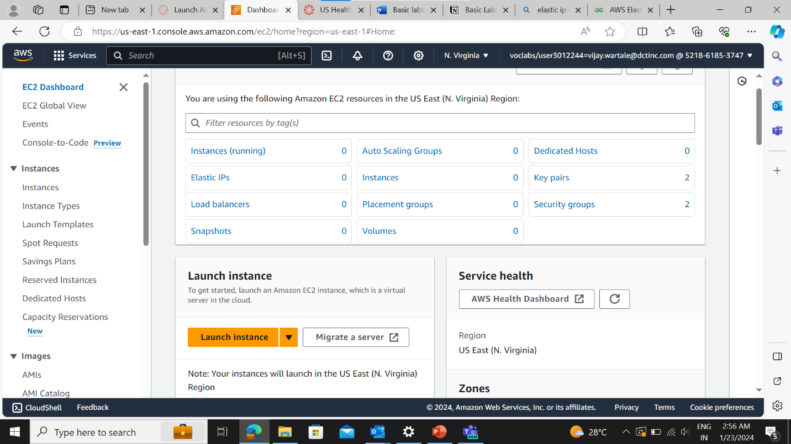

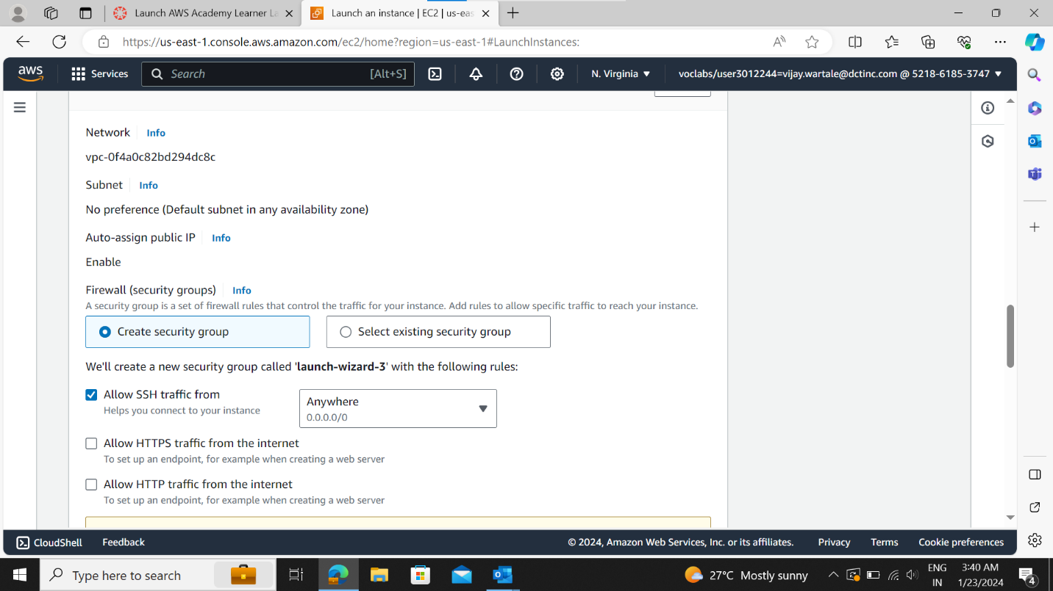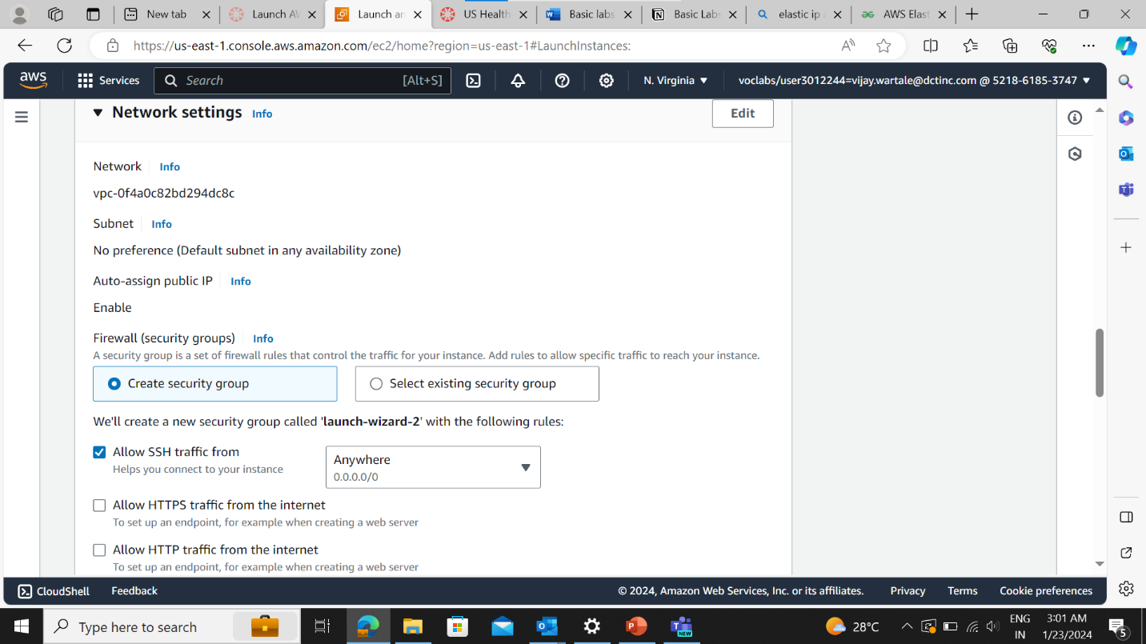

Choose instance type

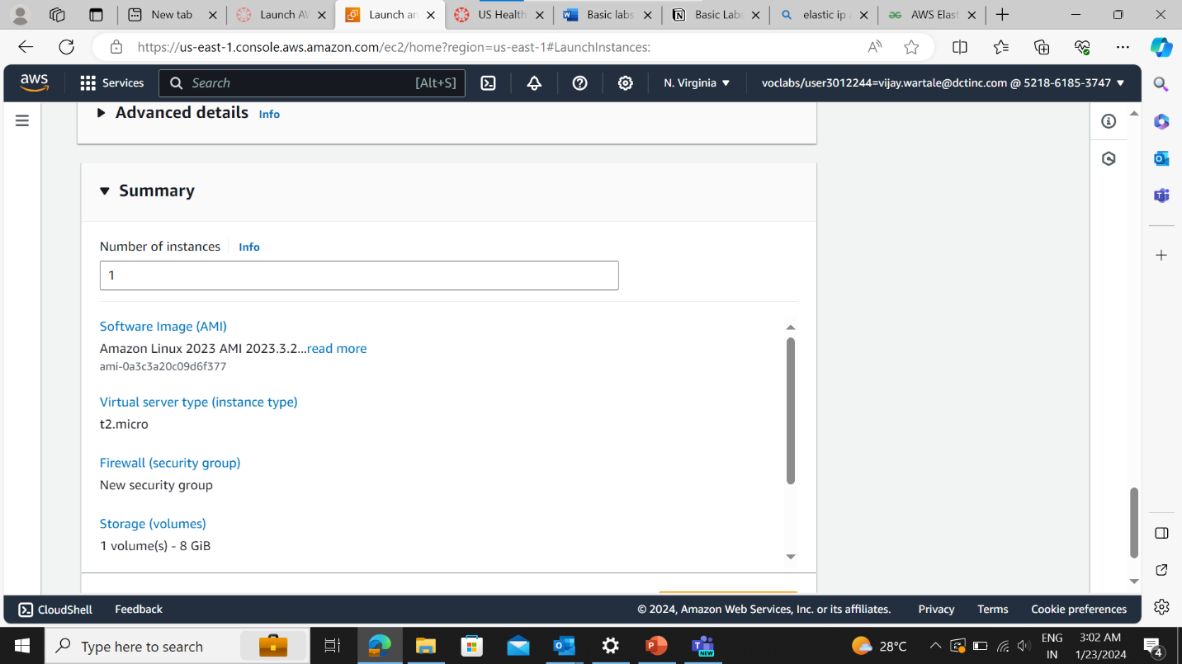

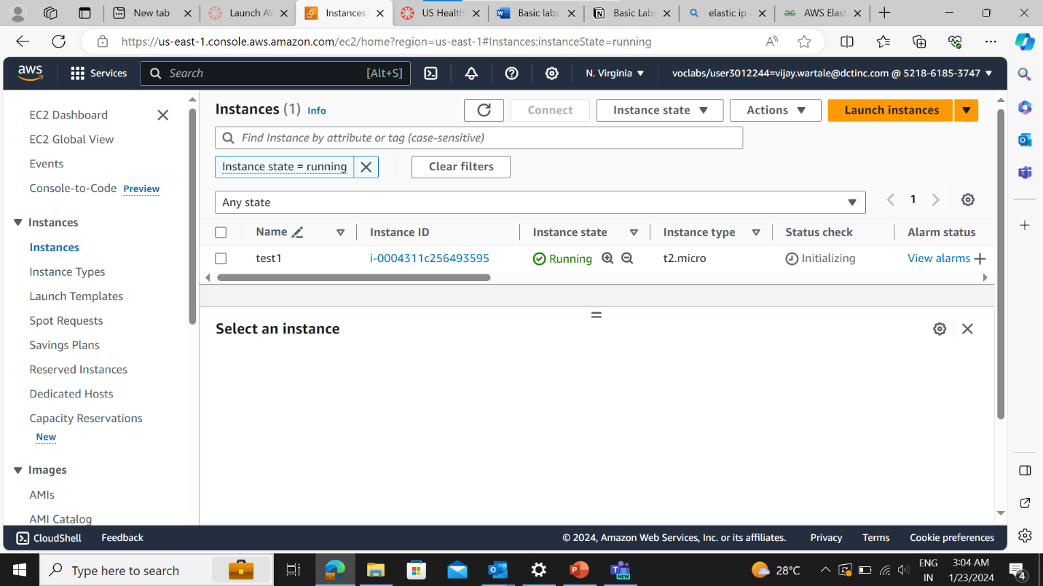

Allocate Elastic Ip address and then associating it to instance

The instance is created and it is in running state

Allocate Elastic ip address and then associate it to the instance

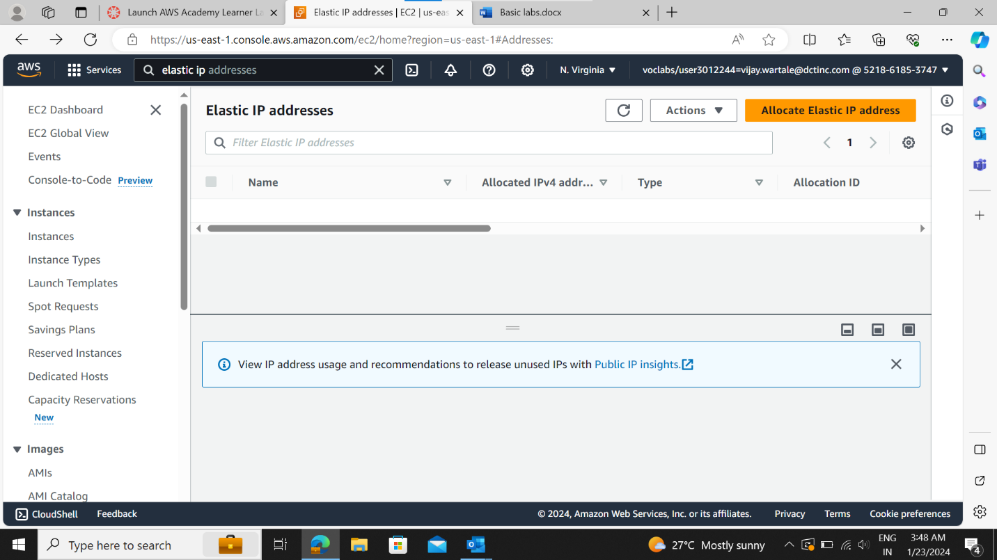

Select the network border group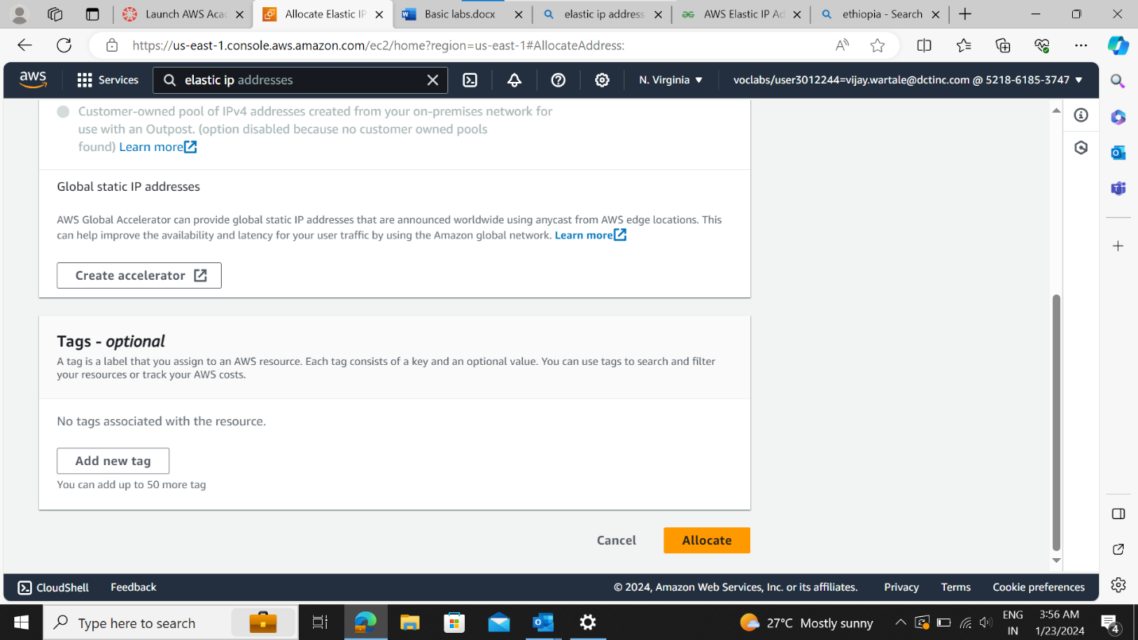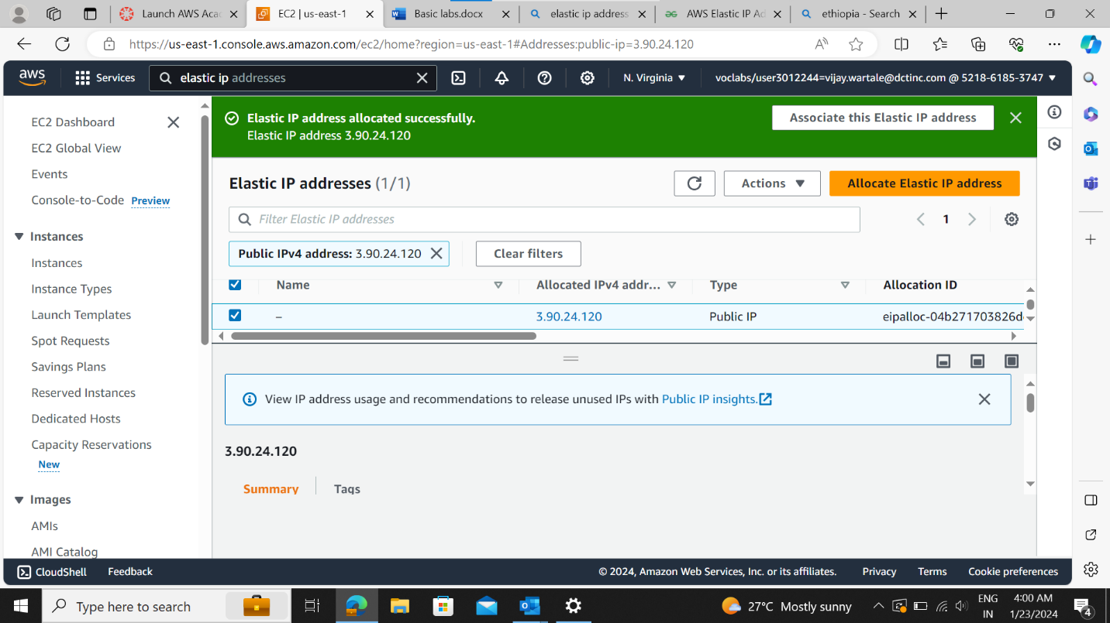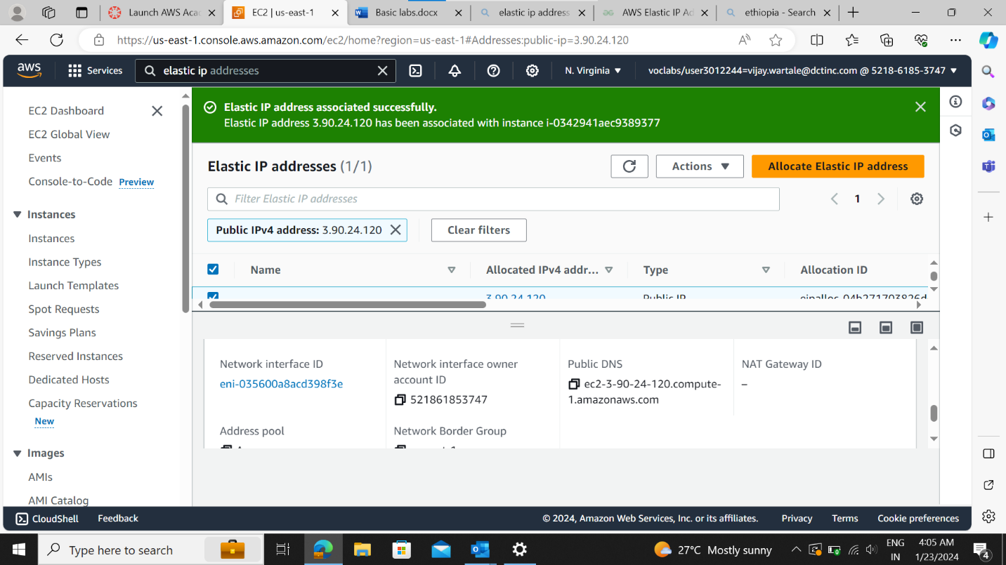

Select the resource type , instance id.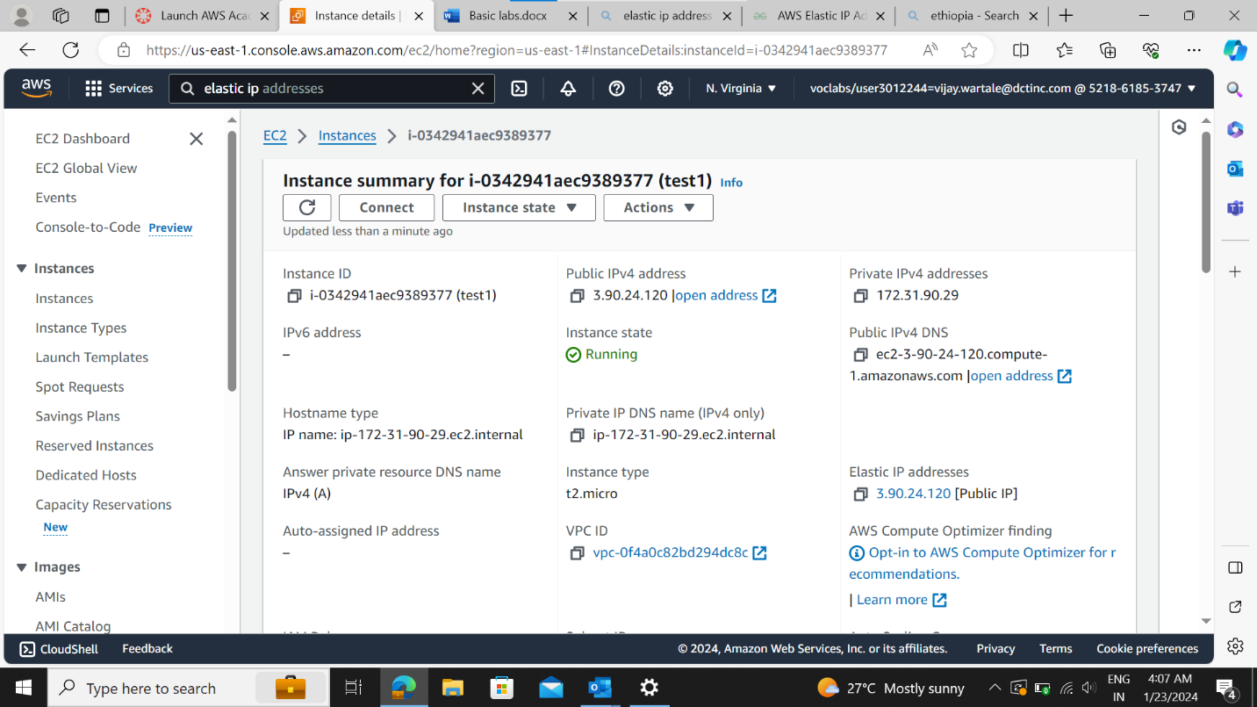

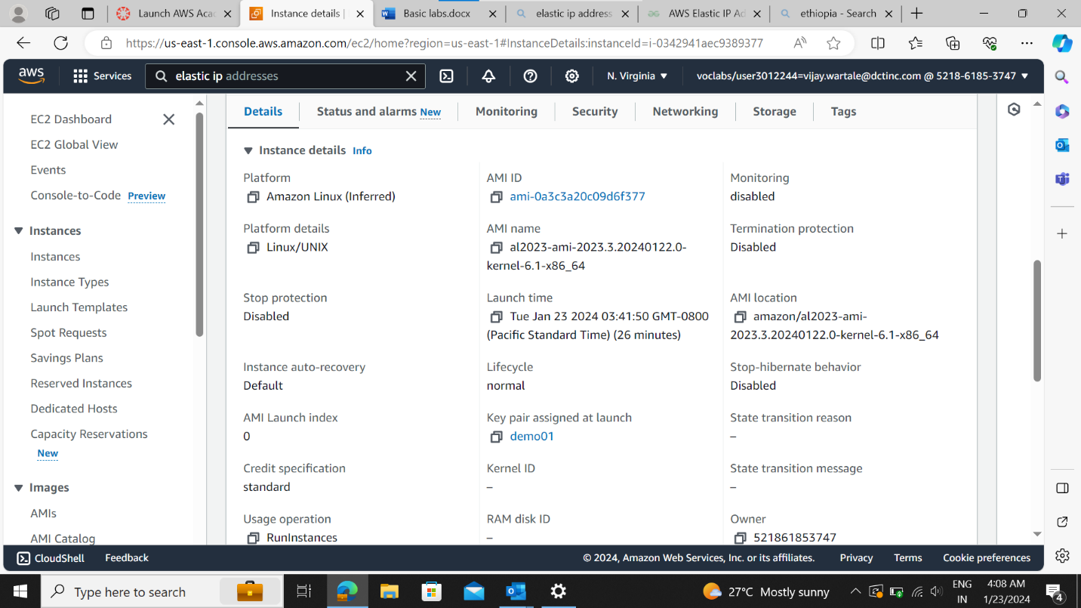

Now connecting the instance to SSH Shell

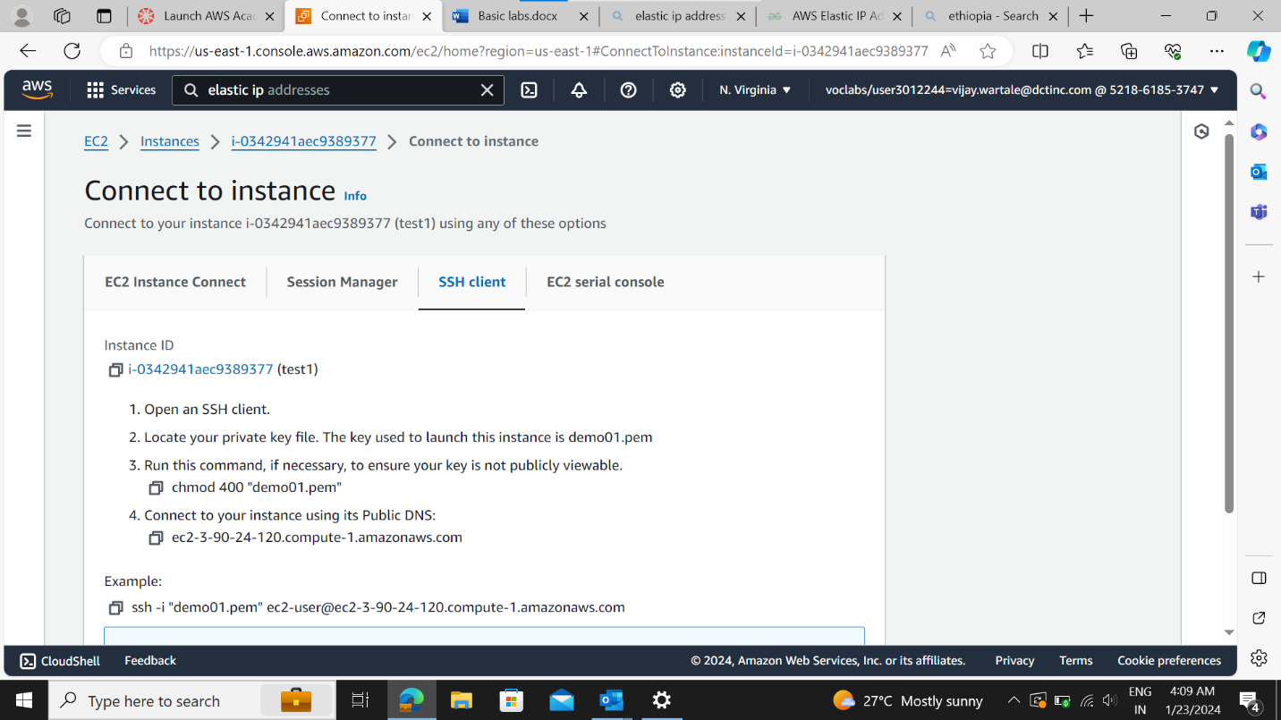

NN

Open command prompt in windows

Give command -> ssh -I <name of pem file> <username>@IPV4 PUBLIC DNS> OR copy the same command as shown the above window 